**CAPSTONE PROJECT**

**ASSIGNMENT -1**

Course code:CSA-1450

Course-COMPILER DESIGN FOR AUTOMATA

Name: K.D.P.Swetha

Reg No:192210372

Name: S.Tejasree

Reg No:192210243

Slot:A

Title: Security Aspects in Compiler Construction

**SUPERVISOR**:

DR.*GNANAJEYARAMAN*

**Assignment Description**

* The project is to conduct a comprehensive analysis of a given dataset. This involves defining the scope, data collection, cleaning, and exploratory data analysis (EDA).
* This involves a multifaceted analysis and implementation approach to ensure the development of secure compilers. The project's primary objectives are to identify potential vulnerabilities in compiler design, propose and implement security measures, and assess the overall robustness of the compiled code.

**Data Collection and Preparation**

**Identify the data sources**

Security aspects of compiler construction involve ensuring that compilers are designed and implemented with considerations for preventing vulnerabilities and protecting against potential security threats.

**Develop a data collection plan**

Clearly articulate the goals of the data collection plan, specifying the security aspects of interest in compiler construction. Define the scope, such as whether it focuses on specific languages, platforms, or compiler components. Identify and engage with key stakeholders involved in compiler construction, including developers, security experts, and project managers.

**Cleanse and preprocess the collected data to ensure data quality**

Identify and handle missing data appropriately. Depending on the extent of missing data, you can choose to impute missing values using statistical measures or remove rows/columns with significant missing values.

**Consistency of the project**

Implement a robust testing strategy, including unit tests, integration tests, and security tests. Automated testing ensures that changes made to the codebase do not introduce new security vulnerabilities and helps catch inconsistencies early in the development process.

**Exploratory Data Analysis (EDA)**

**Conduct exploratory data analysis**

Understand the types of data you are dealing with. This may include source code files, compiler configurations, security rules, or any other relevant information. Ensure that you have a clear understanding of the structure and format of these data.

**Understand the patterns and trends**

* Investigate the adoption of security features in modern compiler designs. This includes examining how compilers implement security mechanisms such as stack canaries, address space layout randomization (ASLR), and data execution prevention (DEP).
* Explore how compiler designers mitigate common vulnerabilities like buffer overflows, injection attacks, and other security threats. Identify trends in the use of techniques like bounds checking, static analysis, and code instrumentation for security enhancement.

**Visualize the data using charts, graphs**

Create histograms or box plots to illustrate the distribution of code metrics such as lines of code, cyclomatic complexity, or code duplication. This can provide insights into the overall code quality and potential security risks.

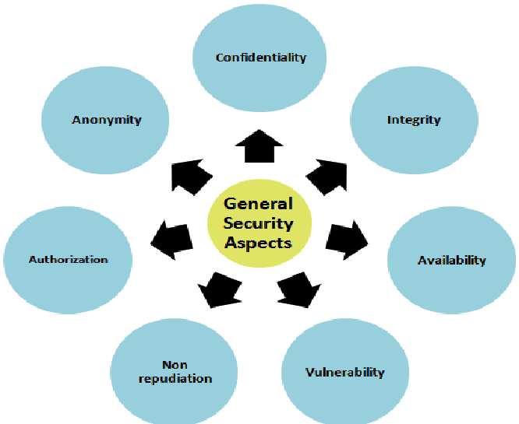

**2. Problem Statement**

Identify and address subtle, yet exploitable, vulnerabilities in the compiler codebase, such as buffer overflows, injection attacks, and privilege escalation issues.

Evaluate and integrate modern security features into the compiler design, such as stack canaries, address space layout randomization (ASLR), control-flow integrity (CFI), and data execution prevention (DEP).

Develop and implement dynamic analysis techniques within the compiler to monitor runtime behaviour, detect anomalies, and prevent potential security threats during program execution.

The successful resolution of these challenges will result in a compiler design that not only ensures the correctness and efficiency of code generation but also prioritizes security

**3.Abstract**

The severe financial and social ramifications of such data leakage, the need for secure memory has become critical. However, working with secure memories can have performance, power, and code size overheads since accessing a secure memory involves additional overheads for encryption/decryption and/or password checks. In addition, an application code may need to be restructured to work under such a memory system. In this paper, we propose a compiler-directed strategy to generate code for a secure memory based embedded architecture. The idea is to let the programmer mark certain data elements, called the seed elements, as secure (i.e., need to be stored in secure memory), and let the compiler determine the remaining secure elements automatically. We also address the problem of code size increase due to our strategy. The experimental results obtained through simulations clearly show that the proposed approach is effective in reducing the total secure memory size. The results also indicate that it is possible to reduce the resulting code size increase by clustering accesses to secure memory.

**4. Proposed Design Work**

**4.1 Identify the Key Components**

**The key components of the proposed design include**

**Security Checks Module**

* **Purpose:** Dedicated module for implementing security checks throughout the compilation process.
* **Security Aspect:** Perform static analysis for common security vulnerabilities, including buffer overflows, injection attacks, and other code-level vulnerabilities.

**Integration with Security Tools**

* **Purpose:** Collaborate with external security tools and libraries for enhanced security analysis.
* **Security Aspect:** Facilitate seamless integration with security analysis tools for dynamic and static code analysis.

**4.2 Functionality**

Implement secure tokenization techniques to prevent common injection vulnerabilities. Detect and handle potentially malicious code patterns during lexical analysis. Perform security-aware optimizations to enhance code robustness.

Ensure robust error handling to prevent information disclosure. Implement strict parsing rules to prevent syntax-based vulnerabilities. Detect and handle ambiguous or potentially dangerous syntax constructs. Enforce secure parsing of input to mitigate injection attacks.

**4.3 Architectural Design**

The secure compiler architecture is designed to incorporate security features seamlessly throughout the compilation process. It focuses on preventing common vulnerabilities, ensuring the integrity of the generated code, and facilitating the integration of security analysis tools.

The architectural design for the security aspects of the compiler ensures that security considerations are embedded at every stage of the compilation process. The integration of security features, secure coding practices, and the ability to leverage security analysis tools collectively contribute to the development of a compiler that produces secure and resilient executable code.

**5. UI Design**

**5.1 Layout Design**

A centralized dashboard providing an overview of the compiler's security status. Key security metrics (e.g., number of security rule violations, analysis results). Allow users to configure security settings and preferences. Recommendations for code improvement

Security feature toggles (e.g., stack canaries, ASLR, DEP).Compiler hardening options. Configuration for integrated security analysis tools. Visual representation of the code with highlighted security issues Detailed breakdown of security vulnerabilities found.

**5.2 Feasible Elements Used**

Incorporate static code analysis tools into the compiler workflow Enable developers to receive feedback on potential security vulnerabilities during compilation.

Implement CFI to protect against control-flow hijacking attacks. Ensure compatibility with the compiler's optimization and code generation processes. Implement secure memory management practices to prevent common memory-related vulnerabilities.

**5.3 Elements and Functions**

Utilize a robust parser with strict parsing rules to prevent syntax-based vulnerabilities. Implement security checks for ambiguous or potentially dangerous syntax constructs. Secure code generation algorithms, hardware-specific optimizations

Enforce secure parsing to mitigate injection attacks. Optimize code for performance without sacrificing security. Algorithms for optimizing security-related constructs.

**6. Login Template**

**6.1 Login Process**

Cryptographic hash functions. Hash and securely store user passwords to prevent exposure in case of a data breach. Enforce access controls to limit user privileges based on roles.

One-time passcodes, biometric data . Implement MFA to add an extra layer of security during the login process. Manage user sessions securely to prevent unauthorized access. Have a well-defined plan to respond to login-related security incidents promptly.

**6.2 Sign-up Process**

Enforce strong password policies, including a minimum length, a combination of uppercase and lowercase letters, numbers, and special characters. Store passwords securely using strong hashing algorithms like crypts or Argon2.

Implement account lockout mechanisms to prevent brute-force attacks. Implement secure session management techniques to protect against session hijacking and fixation.

**6.3 Other Templates**

Follow secure coding practices and design principles throughout the compiler construction process. Implement the principle of least privilege to minimize the attack surface.

Implement rigorous input validation to prevent buffer overflows, injection attacks, and other vulnerabilities. Sanitize input from external sources, including user inputs and files, to prevent malicious code injection.

**7. Conclusion**

In conclusion, addressing security aspects in the context of compiler construction is indispensable for ensuring the reliability, integrity. Prioritize security from the initial design phase, integrating secure coding practices, and adhering to principles like the principle of least privilege. Employ secure design patterns and practices to minimize the attack surface and enhance the overall resilience of the compiler.

Implement rigorous input validation and sanitization techniques to prevent common vulnerabilities such as buffer overflows and injection attacks. Ensure robust handling of user inputs and external data sources to eliminate potential security loopholes.

Conduct thorough static analysis and code reviews to identify and rectify security vulnerabilities early in the development process. Combine automated tools with manual inspections to ensure the correctness, security, and adherence to best practices in the compiler codebase.